Converting Units:

Directions: Use your foldable to find measurement facts. Create ratio to change the measurement from one unit to the next.

Example 1:
How many gallons is equivalent to 20 quarts?
1st: Find the measurement fact(s) that you need and create a ratio.

2nd: Use the information in the problem to set up equivalent ratio. Make sure your units match up!

3rd: Multiply or divide to find the missing information.

Example 2:

A container holds 2,500 milliliters of water. How many liters can the container hold?

1st: Find the measurement fact(s) that you need and create a ratio.

2nd: Use the information in the problem to set up equivalent ratio. Make sure your units match up!

3rd: Multiply or divide to find the missing information.

Practice:

- How many grams are in 2 kilograms? _________

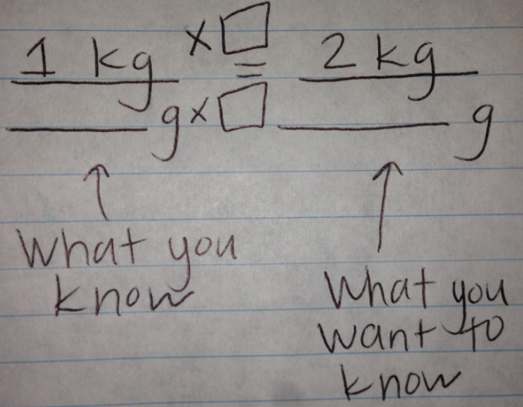

- 9 pints = ___________ cups

- How many centimeters are in 90 millimeters?

- 60 inches = _________ feet

- How many meters are in 800 kilometers?

- 70 inches = ___________ feet

- An item weighs 4,500 grams. How many kilograms does it weigh?

- You need 105 mL of water for an experiment. How many liters of water do you need?

